Summary of Legislative Action

Senate Sponsors Maryland Health Security Act 2010 sb682:

Senator Paul G. Pinsky, District 22
Senator Nathaniel Exum, District 24
Senator Jennie M. Forehand, District 17
Senator Lisa A. Gladden, District 41
Senator David C. Harrington, District 47
Senator Verna L. Jones, District 44
Senator Delores G. Kelley, District 10
Senator Mike Lenett, District 19
Senator Richard S. Madaleno, Jr., District 18
Senator Nathaniel J. McFadden, District 45
Senator Catherine E. Pugh, District 40
Senator Jamie Raskin, District 20

Senate Action
2/10
First Reading Finance
2/24
Hearing 3/10 at 1:00 p.m.
3/22
Unfavorable Report by Finance

The vote was 8-3 against with Della, Exum and Pugh supporting. Co-sponsor Delores G. Kelley voted against the bill in the Finance Committee.

Web Link:

http://mlis.state.md.us/2010rs/billfile/sb0682.htm

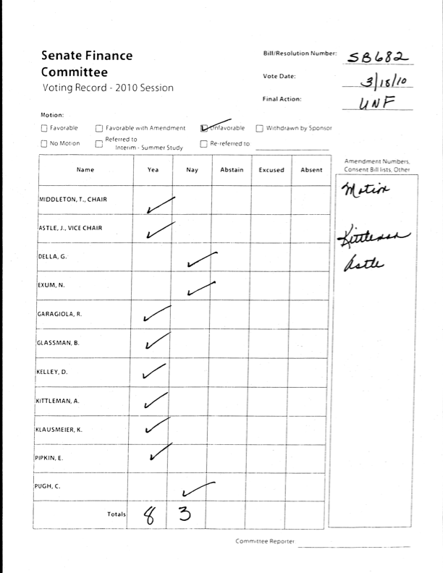

House of Delegate Sponsors of Maryland Health Security Act 2010 hb767:

Delegate Karen S. Montgomery, District 14
Delegate Saqib Ali, District 39
Delegate Curt Anderson, District 43
Delegate Charles Barkley, District 39
Delegate Joanne C. Benson, District 24
Delegate Elizabeth Bobo, District 12B
Delegate William A. Bronrott, District 16
Delegate Alfred C. Carr, Jr., District 18
Delegate Jill P. Carter, District 41
Delegate Virginia P. Clagett, District 30
Delegate Galen R. Clagett, District 3A
Delegate Frank M. Conaway, Jr., District 40
Delegate C. William Frick, District 16
Delegate Barbara Frush, District 21
Delegate Tawanna P. Gaines, District 22
Delegate Jim Gilchrist, District 17
Delegate Ana Sol Gutierrez, District 18
Delegate Sheila E. Hixson, District 20
Delegate Carolyn J. B. Howard, District 24
Delegate James W. Hubbard, District 23A
Delegate Tom Hucker, District 20
Delegate Jolene Ivey, District 47
Delegate Anne R. Kaiser, District 14
Delegate Susan C. Lee, District 16
Delegate Roger P. Manno, District 19
Delegate Shirley Nathan-Pulliam, District 10
Delegate Doyle L. Niemann, District 47
Delegate Nathaniel T. Oaks, District 41
Delegate Joseline A. Pena-Melnyk, District 21
Delegate Victor R. Ramirez, District 47
Delegate Kirill Reznik, District 39
Delegate Craig L. Rice, District 15
Delegate Barbara Robinson, District 40
Delegate Samuel I. Rosenberg, District 41
Delegate Herman L. Taylor, Jr., District 14
Delegate Frank S. Turner, District 13
Delegate Veronica Turner, District 26
Delegate Jeff Waldstreicher, District 18

House Action
2/5
First Reading Health and Government Operations
3/3
Hearing 3/18 at 1:00 p.m.
3/27
Unfavorable Report by Health and Government Operations

The vote in the House Government and Operations Committee was 7-16; voting for the bill were Montgomery, Pena-Melnyk, Oaks, D. Riley,
Morhaim, Nathan-Pulliam, and J. Benson. Co-sponsors who voted against the bill were Veronica Turner, James Hubbard and Kirill Reznik. Shane Pendergrass had been a public supporter but also voted against hb767.

Web Link:

http://mlis.state.md.us/2010rs/billfile/hb0767.htm

